Artificial Intelligence  
Lab Exercise 6  
Unification and Resolution

short line

Ashwin Prakash  
RA1911026010048

**Unification:**

Unification is a process of making two different logical atomic expressions identical by finding a substitution. Unification takes two literals as input and makes them identical using substitution.

**Aim:**

To implement Unification for real world problems

**Problem Statement:**

To implement unification for real world problems and then verify it by doing manual calculation.

**Algorithm:**

1. Initialize the substitution set to be empty.
2. Recursively unify atomic sentences:
3. Check for Identical expression match.
4. If one expression is a variable vi, and the other is a term ti which does not contain variable vi, then:

* Substitute ti / vi in the existing substitutions
* Add ti /vi to the substitution setlist.
* If both the expressions are functions, then function name must be similar, and the number of arguments must be the same in both the expression.

**Program:**

def get_index_comma(string):

    index_list = list()

    par_count = 0

    for i in range(len(string)):

        if string[i] == ',' and par_count == 0:

            index_list.append(i)

        elif string[i] == '(':

            par_count += 1

        elif string[i] == ')':

            par_count -= 1

    return index_list

def is_variable(expr):

    for i in expr:

        if i == '(' or i == ')':

            return False

    return True

def process_expression(expr):

    expr = expr.replace(' ', '')

    index = None

    for i in range(len(expr)):

        if expr[i] == '(':

            index = i

            break

    predicate_symbol = expr[:index]

    expr = expr.replace(predicate_symbol, '')

    expr = expr[1:len(expr) - 1]

    arg_list = list()

    indices = get_index_comma(expr)

    if len(indices) == 0:

        arg_list.append(expr)

    else:

        arg_list.append(expr[:indices[0]])

        for i, j in zip(indices, indices[1:]):

            arg_list.append(expr[i + 1:j])

        arg_list.append(expr[indices[len(indices) - 1] + 1:])

    return predicate_symbol, arg_list

def get_arg_list(expr):

    _, arg_list = process_expression(expr)

    flag = True

    while flag:

        flag = False

        for i in arg_list:

            if not is_variable(i):

                flag = True

                _, tmp = process_expression(i)

                for j in tmp:

                    if j not in arg_list:

                        arg_list.append(j)

                arg_list.remove(i)

    return arg_list

def check_occurs(var, expr):

    arg_list = get_arg_list(expr)

    if var in arg_list:

        return True

    return False

def unify(expr1, expr2):

    if is_variable(expr1) and is_variable(expr2):

        if expr1 == expr2:

            return 'Null'

        else:

            return False

    elif is_variable(expr1) and not is_variable(expr2):

        if check_occurs(expr1, expr2):

            return False

        else:

            tmp = str(expr2) + '/' + str(expr1)

            return tmp

    elif not is_variable(expr1) and is_variable(expr2):

        if check_occurs(expr2, expr1):

            return False

        else:

            tmp = str(expr1) + '/' + str(expr2)

            return tmp

    else:

        predicate_symbol_1, arg_list_1 = process_expression(expr1)

        predicate_symbol_2, arg_list_2 = process_expression(expr2)

        if predicate_symbol_1 != predicate_symbol_2:

            return False

        elif len(arg_list_1) != len(arg_list_2):

            return False

        else:

            sub_list = list()

            for i in range(len(arg_list_1)):

                tmp = unify(arg_list_1[i], arg_list_2[i])

                if not tmp:

                    return False

                elif tmp == 'Null':

                    pass

                else:

                    if type(tmp) == list:

                        for j in tmp:

                            sub_list.append(j)

                    else:

                        sub_list.append(tmp)

            return sub_list

if __name__ == '__main__':

    f1 = 'Q(a, g(x, a), f(y))'

    f2 = 'Q(a, g(f(b), a), x)'

    result = unify(f1, f2)

    if not result:

        print('The process of Unification failed!')

    else:

        print('The process of Unification successful!')

        print(result)

**Output:**

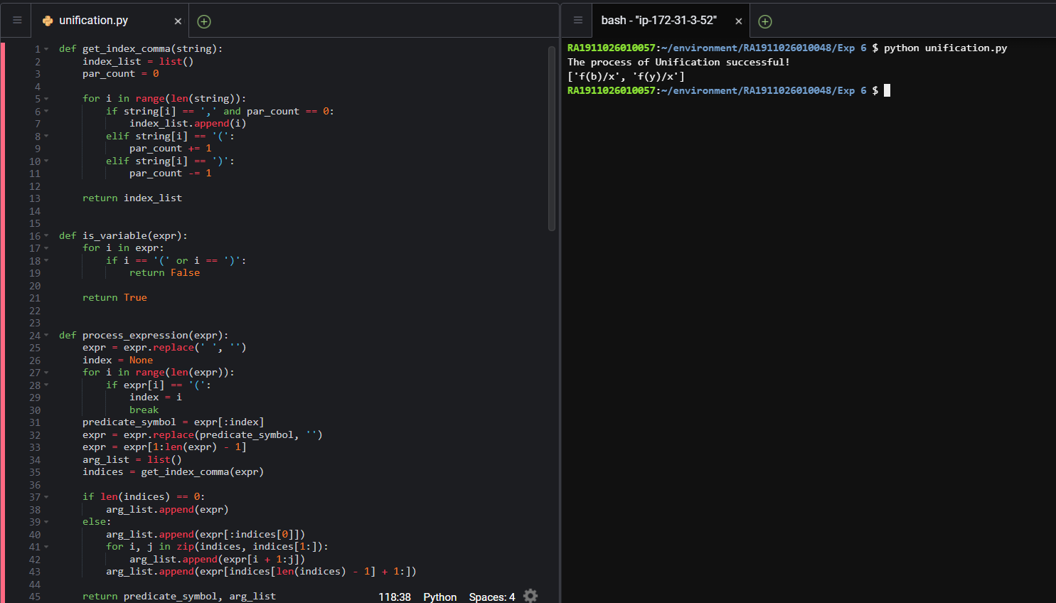

**Observations:**

By Manual Calculation,

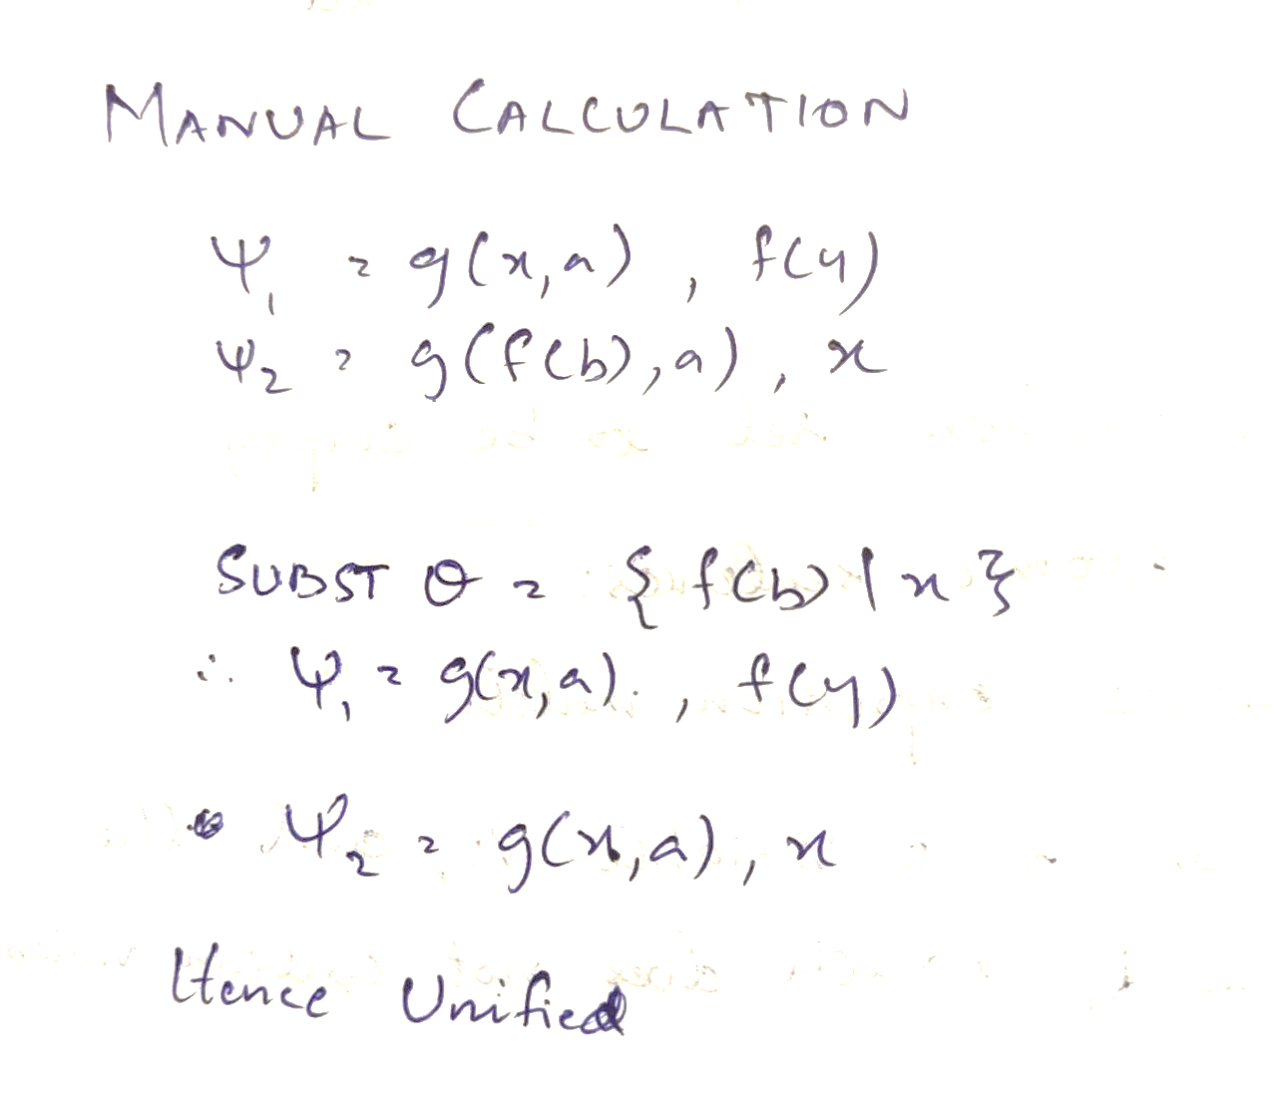

**Inference:**

The result of both Code Output and Manual Calculation Output are the same

**Result:**

We have implemented Unification for a real world problem.

**Resolution:**

Resolution is a theorem proving technique that proceeds by building refutation proofs, i.e., proofs by contradictions. It was invented by a Mathematician John Alan Robinson in the year 1965.

Resolution is used, if there are various statements are given, and we need to prove a conclusion of those statements.

**Aim:**

To implement Resolution for real world problems

**Problem Statement:**

To implement resolution for real world problems and then verify it by doing manual calculation.

**Algorithm:**

1. Conversion of facts into first-order logic.

2. Convert FOL statements into CNF

1. **Eliminate all implication (→) and rewrite**
2. **Move negation (¬)inwards and rewrite**
3. **Rename variables or standardize variables**
4. **Eliminate existential instantiation quantifier by elimination.**
5. **Drop Universal quantifiers.**

3. Negate the statement which needs to prove (proof by contradiction)

4. Draw resolution graph (unification).

**Program:**

import copy

import time

class Parameter:

    variable_count = 1

    def __init__(self, name=None):

        if name:

            self.type = "Constant"

            self.name = name

        else:

            self.type = "Variable"

            self.name = "v" + str(Parameter.variable_count)

            Parameter.variable_count += 1

    def isConstant(self):

        return self.type == "Constant"

    def unify(self, type_, name):

        self.type = type_

        self.name = name

    def __eq__(self, other):

        return self.name == other.name

    def __str__(self):

        return self.name

class Predicate:

    def __init__(self, name, params):

        self.name = name

        self.params = params

    def __eq__(self, other):

        return self.name == other.name and all(a == b for a, b in zip(self.params, other.params))

    def __str__(self):

        return self.name + "(" + ",".join(str(x) for x in self.params) + ")"

    def getNegatedPredicate(self):

        return Predicate(negatePredicate(self.name), self.params)

class Sentence:

    sentence_count = 0

    def __init__(self, string):

        self.sentence_index = Sentence.sentence_count

        Sentence.sentence_count += 1

        self.predicates = []

        self.variable_map = {}

        local = {}

        for predicate in string.split("|"):

            name = predicate[:predicate.find("(")]

            params = []

            for param in predicate[predicate.find("(") + 1: predicate.find(")")].split(","):

                if param[0].islower():

                    if param not in local:  # Variable

                        local[param] = Parameter()

                        self.variable_map[local[param].name] = local[param]

                    new_param = local[param]

                else:

                    new_param = Parameter(param)

                    self.variable_map[param] = new_param

                params.append(new_param)

            self.predicates.append(Predicate(name, params))

    def getPredicates(self):

        return [predicate.name for predicate in self.predicates]

    def findPredicates(self, name):

        return [predicate for predicate in self.predicates if predicate.name == name]

    def removePredicate(self, predicate):

        self.predicates.remove(predicate)

        for key, val in self.variable_map.items():

            if not val:

                self.variable_map.pop(key)

    def containsVariable(self):

        return any(not param.isConstant() for param in self.variable_map.values())

    def __eq__(self, other):

        if len(self.predicates) == 1 and self.predicates[0] == other:

            return True

        return False

    def __str__(self):

        return "".join([str(predicate) for predicate in self.predicates])

class KB:

    def __init__(self, inputSentences):

        self.inputSentences = [x.replace(" ", "") for x in inputSentences]

        self.sentences = []

        self.sentence_map = {}

    def prepareKB(self):

        self.convertSentencesToCNF()

        for sentence_string in self.inputSentences:

            sentence = Sentence(sentence_string)

            for predicate in sentence.getPredicates():

                self.sentence_map[predicate] = self.sentence_map.get(

                    predicate, []) + [sentence]

    def convertSentencesToCNF(self):

        for sentenceIdx in range(len(self.inputSentences)):

            if "=>" in self.inputSentences[sentenceIdx]:

                self.inputSentences[sentenceIdx] = negateAntecedent(

                    self.inputSentences[sentenceIdx])

    def askQueries(self, queryList):

        results = []

        for query in queryList:

            negatedQuery = Sentence(negatePredicate(query.replace(" ", "")))

            negatedPredicate = negatedQuery.predicates[0]

            prev_sentence_map = copy.deepcopy(self.sentence_map)

            self.sentence_map[negatedPredicate.name] = self.sentence_map.get(

                negatedPredicate.name, []) + [negatedQuery]

            self.timeLimit = time.time() + 40

            try:

                result = self.resolve([negatedPredicate], [

                                      False]*(len(self.inputSentences) + 1))

            except:

                result = False

            self.sentence_map = prev_sentence_map

            if result:

                results.append("TRUE")

            else:

                results.append("FALSE")

        return results

    def resolve(self, queryStack, visited, depth=0):

        if time.time() > self.timeLimit:

            raise Exception

        if queryStack:

            query = queryStack.pop(-1)

            negatedQuery = query.getNegatedPredicate()

            queryPredicateName = negatedQuery.name

            if queryPredicateName not in self.sentence_map:

                return False

            else:

                queryPredicate = negatedQuery

                for kb_sentence in self.sentence_map[queryPredicateName]:

                    if not visited[kb_sentence.sentence_index]:

                        for kbPredicate in kb_sentence.findPredicates(queryPredicateName):

                            canUnify, substitution = performUnification(

                                copy.deepcopy(queryPredicate), copy.deepcopy(kbPredicate))

                            if canUnify:

                                newSentence = copy.deepcopy(kb_sentence)

                                newSentence.removePredicate(kbPredicate)

                                newQueryStack = copy.deepcopy(queryStack)

                                if substitution:

                                    for old, new in substitution.items():

                                        if old in newSentence.variable_map:

                                            parameter = newSentence.variable_map[old]

                                            newSentence.variable_map.pop(old)

                                            parameter.unify(

                                                "Variable" if new[0].islower() else "Constant", new)

                                            newSentence.variable_map[new] = parameter

                                    for predicate in newQueryStack:

                                        for index, param in enumerate(predicate.params):

                                            if param.name in substitution:

                                                new = substitution[param.name]

                                                predicate.params[index].unify(

                                                    "Variable" if new[0].islower() else "Constant", new)

                                for predicate in newSentence.predicates:

                                    newQueryStack.append(predicate)

                                new_visited = copy.deepcopy(visited)

                                if kb_sentence.containsVariable() and len(kb_sentence.predicates) > 1:

                                    new_visited[kb_sentence.sentence_index] = True

                                if self.resolve(newQueryStack, new_visited, depth + 1):

                                    return True

                return False

        return True

def performUnification(queryPredicate, kbPredicate):

    substitution = {}

    if queryPredicate == kbPredicate:

        return True, {}

    else:

        for query, kb in zip(queryPredicate.params, kbPredicate.params):

            if query == kb:

                continue

            if kb.isConstant():

                if not query.isConstant():

                    if query.name not in substitution:

                        substitution[query.name] = kb.name

                    elif substitution[query.name] != kb.name:

                        return False, {}

                    query.unify("Constant", kb.name)

                else:

                    return False, {}

            else:

                if not query.isConstant():

                    if kb.name not in substitution:

                        substitution[kb.name] = query.name

                    elif substitution[kb.name] != query.name:

                        return False, {}

                    kb.unify("Variable", query.name)

                else:

                    if kb.name not in substitution:

                        substitution[kb.name] = query.name

                    elif substitution[kb.name] != query.name:

                        return False, {}

    return True, substitution

def negatePredicate(predicate):

    return predicate[1:] if predicate[0] == "~" else "~" + predicate

def negateAntecedent(sentence):

    antecedent = sentence[:sentence.find("=>")]

    premise = []

    for predicate in antecedent.split("&"):

        premise.append(negatePredicate(predicate))

    premise.append(sentence[sentence.find("=>") + 2:])

    return "|".join(premise)

def getInput(filename):

    with open(filename, "r") as file:

        noOfQueries = int(file.readline().strip())

        inputQueries = [file.readline().strip() for _ in range(noOfQueries)]

        noOfSentences = int(file.readline().strip())

        inputSentences = [file.readline().strip()

                          for _ in range(noOfSentences)]

        return inputQueries, inputSentences

def printOutput(filename, results):

    print(results)

    with open(filename, "w") as file:

        for line in results:

            file.write(line)

            file.write("\n")

    file.close()

if __name__ == '__main__':

    inputQueries_, inputSentences_ = getInput('input_1.txt')

    knowledgeBase = KB(inputSentences_)

    knowledgeBase.prepareKB()

    results_ = knowledgeBase.askQueries(inputQueries_)

    printOutput("output.txt", results_)

**Output:**

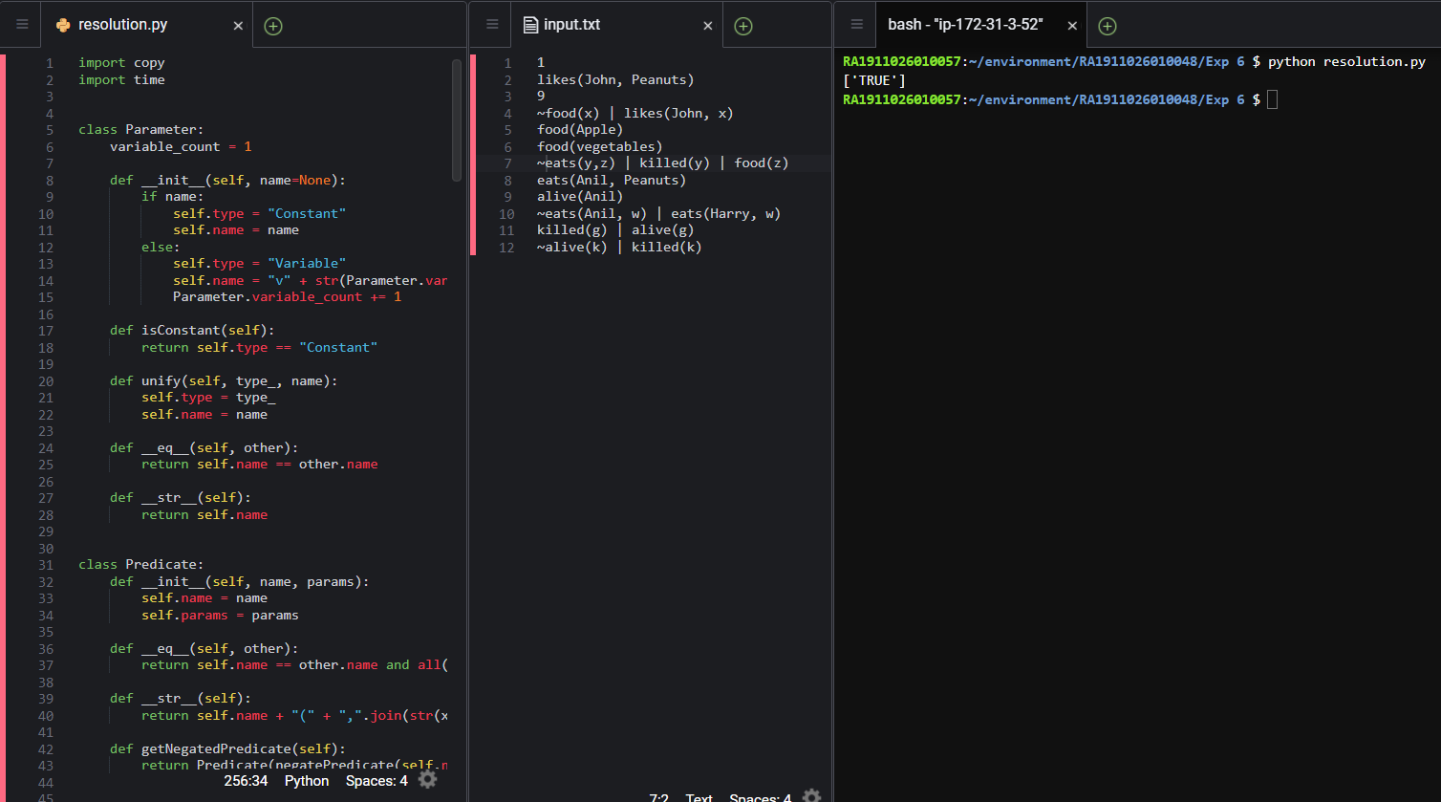

**Observations:**

By Manual Calculations,

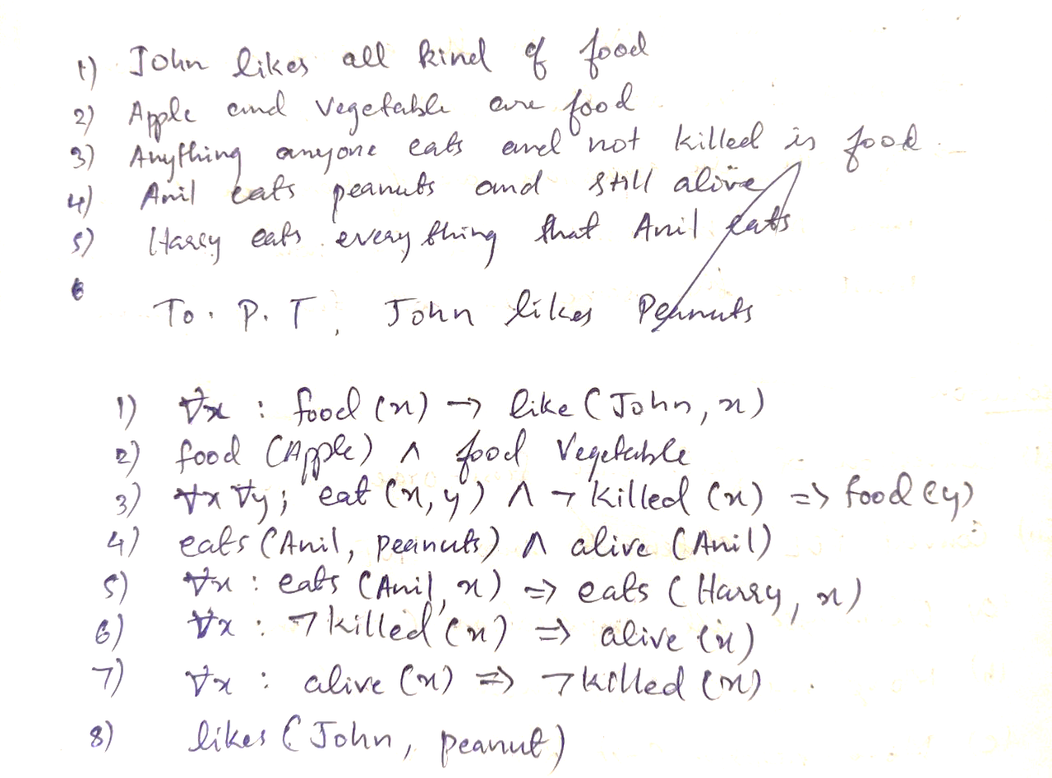

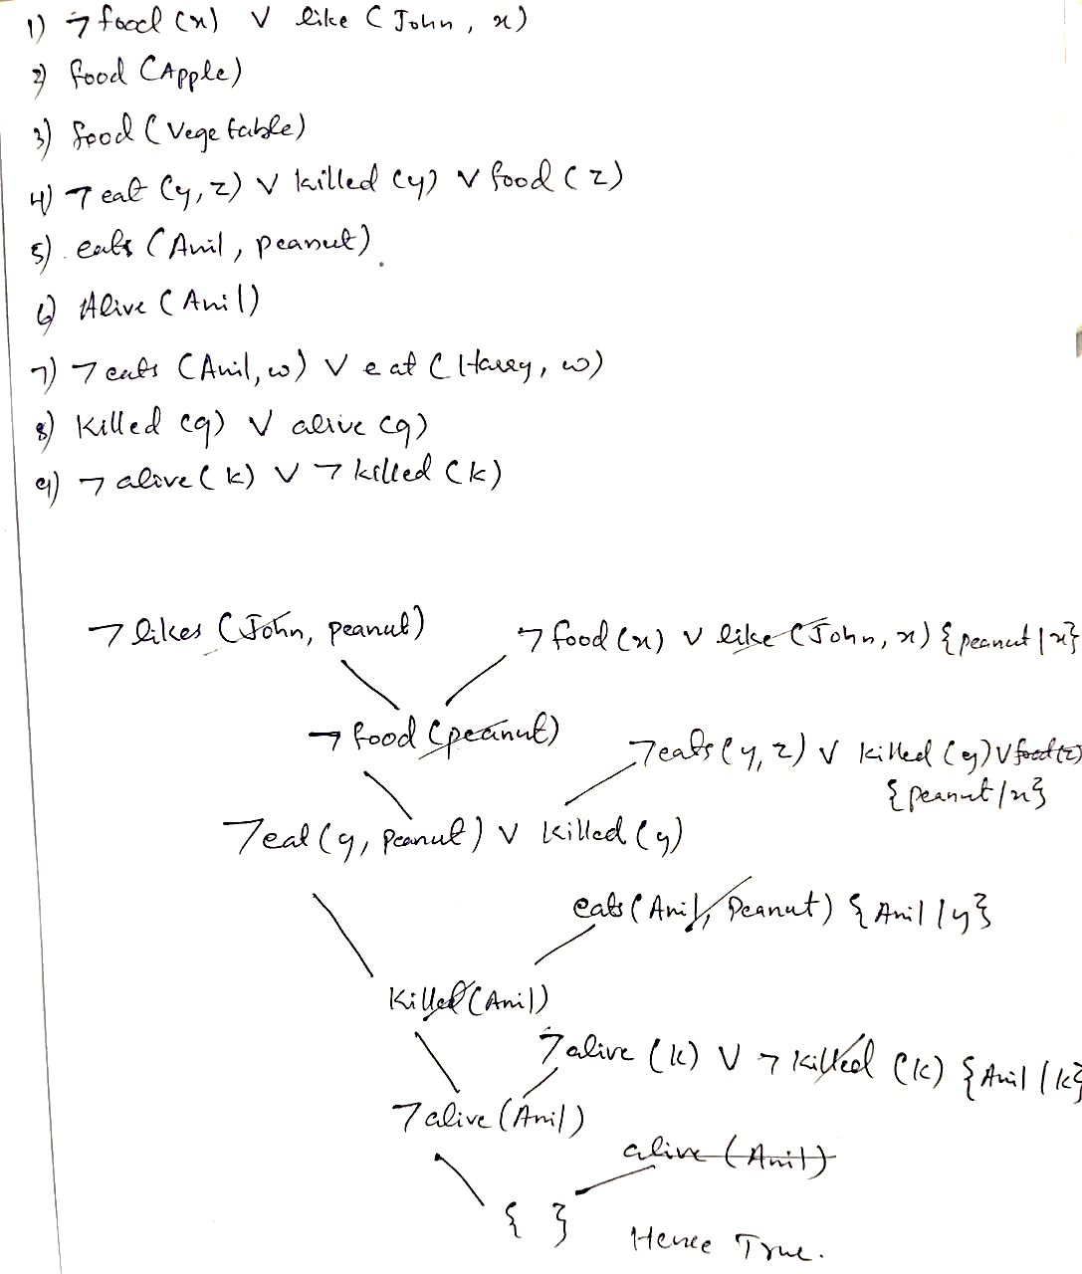

**Inference:**

The result of both Code Output and Manual Calculation Output are the same

**Result:**

We have implemented Resolution for a real world problem.